OUTPUT SCREENS

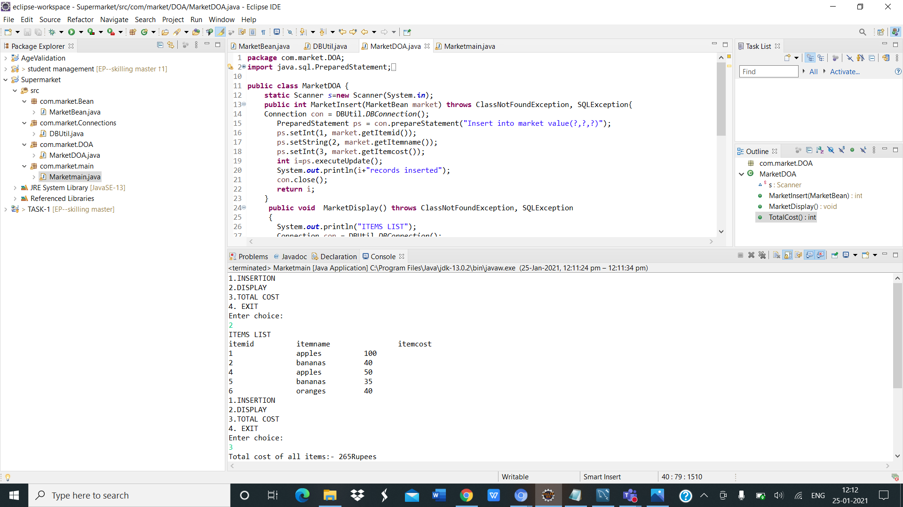

OUTPUT IN MYSQL DATABASE

